**BASH SCRIPTS ASSIGNMENT01**

**Simple output**  
#!/bin/bash  
# Simple output script  
echo "Hello World"

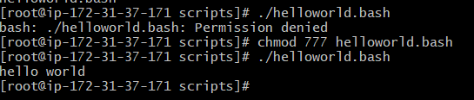

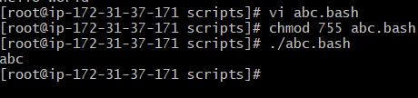

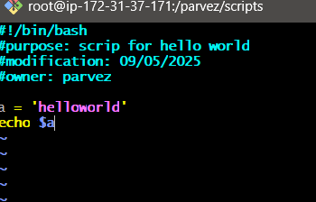

* Variable a = ‘hello world’
* Echo $a – to get variable value.

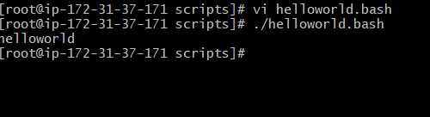

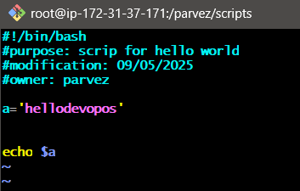

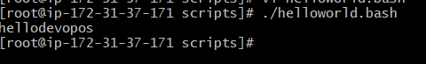

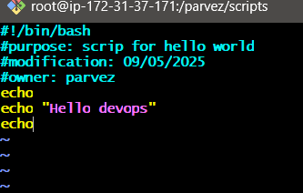

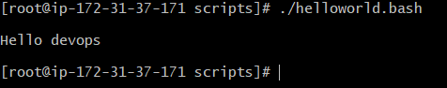

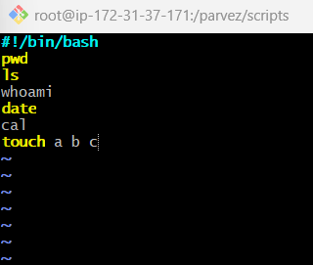________________________________________________________________________

**Commands scripts**

#!bin/bash

Pwd

Ls

Whoami

Cal

Touch a b c



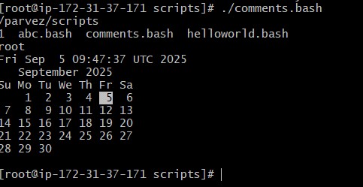

________________________________________________________________________ **Defining variables**

#!/bin/bash

# Example of defining variables

a=parvez

b=mohd

c=Linux class

echo "My first name is $a"

echo "My surname is $b"

echo “I am in $c”

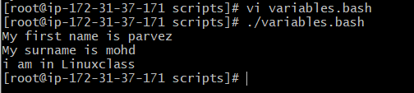

________________________________________________________________________

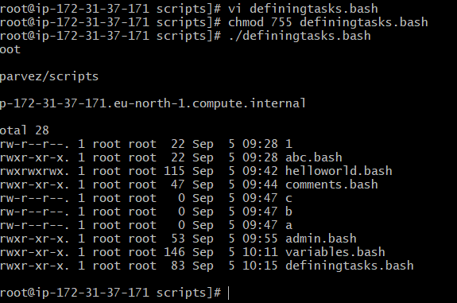**# Define small tasks**

whoami

echo

pwd

echo

hostname

echo

ls -ltr

echo

_______________________________________________________________________________

**Read Input**

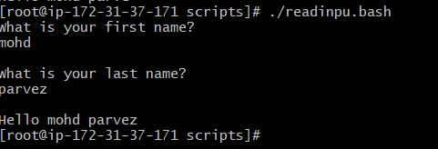#!/bin/bash

# Read user input

echo "What is your first name?"

read a

echo

echo "What is your last name?"

read b

echo

echo Hello $a $b

_______________________________________________________________________________

**Scripts to run commands within**

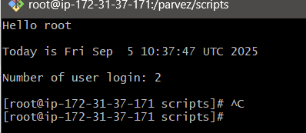

#!/bin/bash

# Script to run commands within

clear

echo "Hello `whoami`"

echo

echo "Today is `date`"

echo

echo "Number of user login: `who | wc -l `"

echo

_______________________________________________________________________________

**Read input and perform a task**

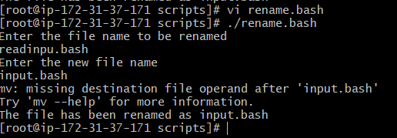#!/bin/bash

# This script will rename a file

echo Enter the file name to be renamed

read readinpu.bsh

echo Enter the new file name

read read.bash

mv $readinpu.bash $read.bash

echo The file has been renamed as $newfilename

**IF SCRIPT**

#!/bin/bash

count=10

if [ $count -eq 100 ]

then

echo count is 100

else

echo count is not 100

fi

output :

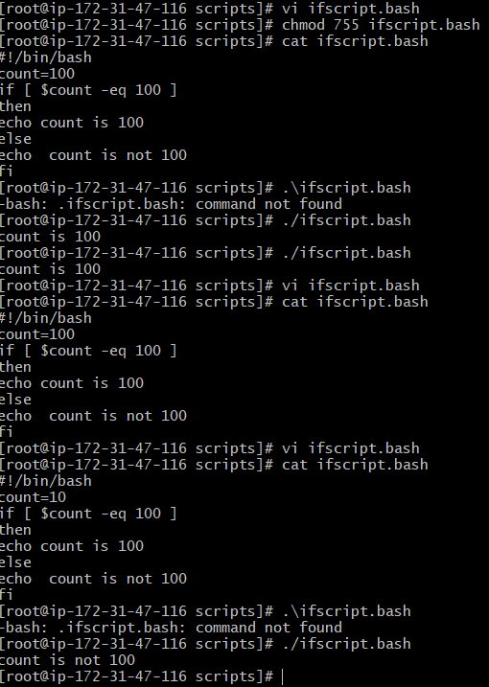

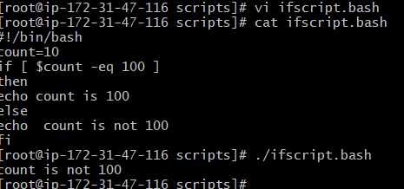

________________________________________________________________________

**case Scripts**: 1

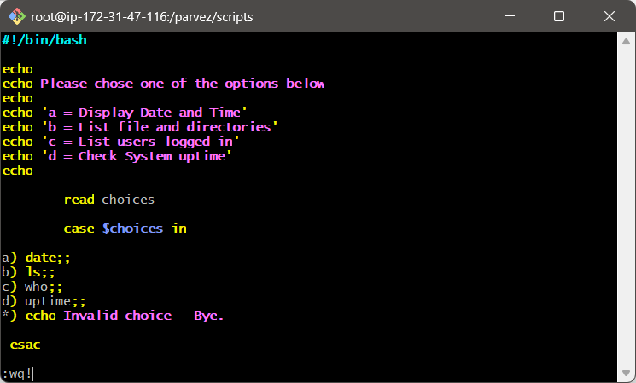#!/bin/bash

echo

echo Please chose one of the options below

echo

echo 'a = Display Date and Time'

echo 'b = List file and directories'

echo 'c = List users logged in'

echo 'd = Check System uptime'

echo

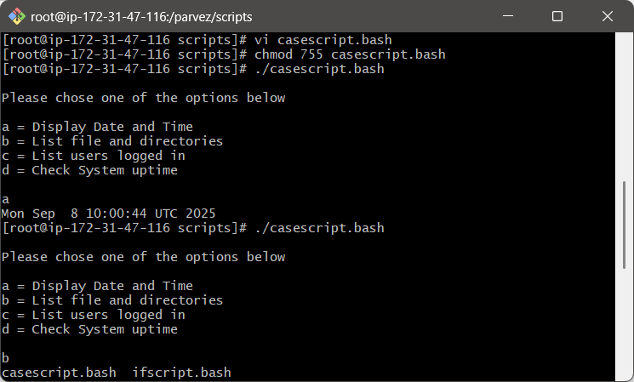

read choices

case $choices in

a) date;;

b) ls;;

c) who;;

d) uptime;;

*) echo Invalid choice - Bye.

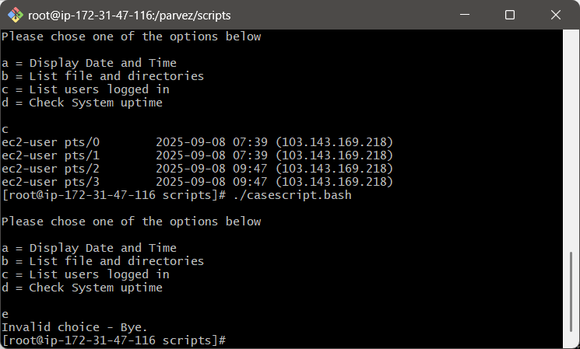

esac

**do-while Script**

1. **Script to run for a number of times**

#!/bin/bash

c=1

while [ $c -le 5 ]

do

echo "Welcone $c times"

(( c++ ))

done

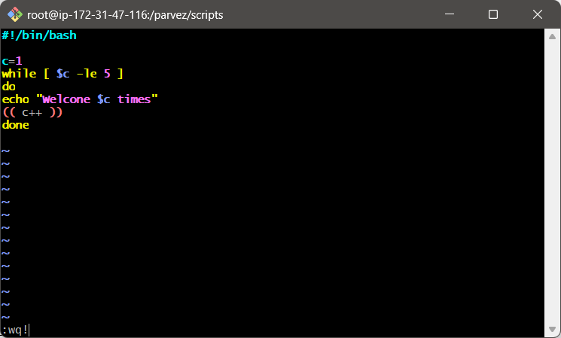

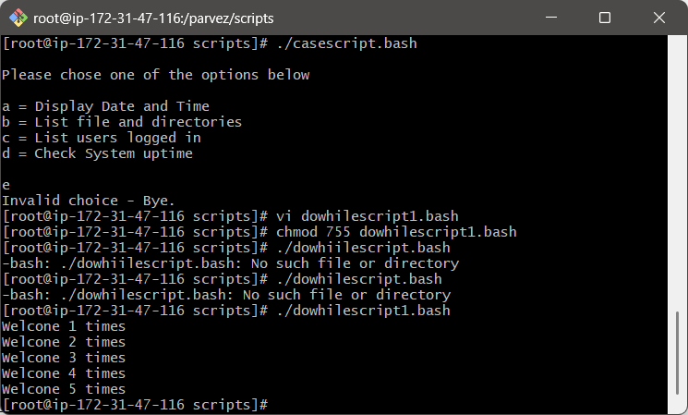



2) **Script to run for a number of seconds**

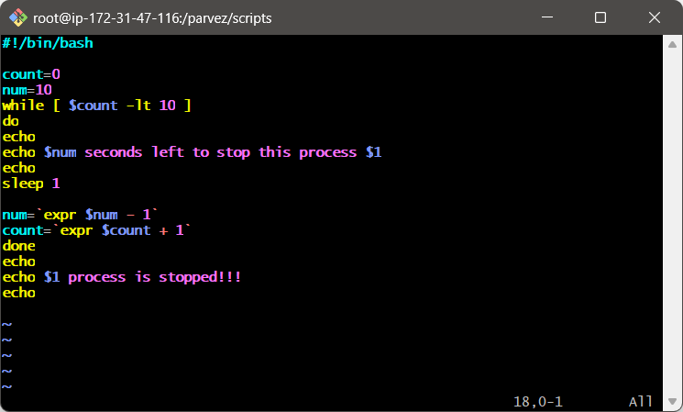#!/bin/bash

count=0

num=10

while [ $count -lt 10 ]

do

echo

echo $num seconds left to stop this process $1

echo

sleep 1

num=`expr $num - 1`

count=`expr $count + 1`

done

echo

echo $1 process is stopped!!!

echo

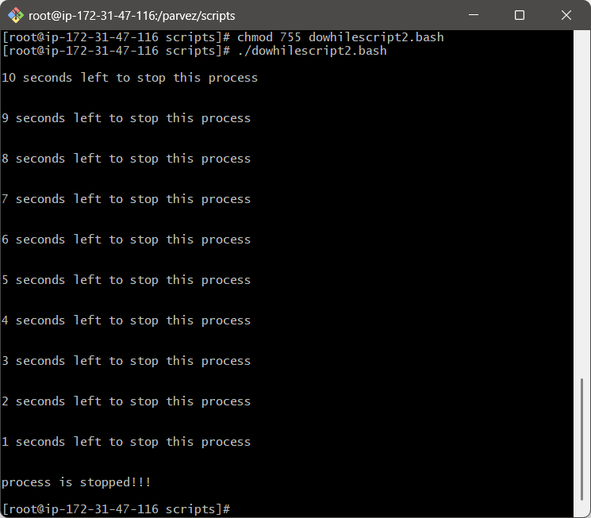

**for loop Scripts**:

1. 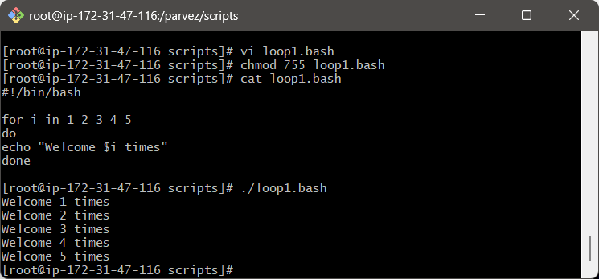**Simple for loop output**

#!/bin/bash

for i in 1 2 3 4 5

do

echo "Welcome $i times"

done

________________________________________________________________________

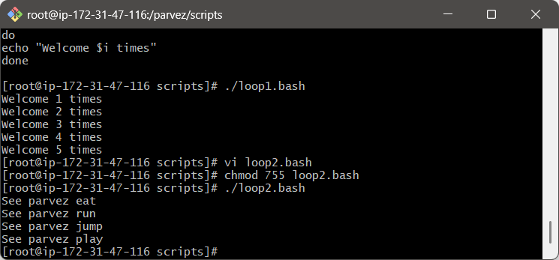

1. **Simple for loop output**

#!/bin/bash

for i in eat run jump play

do

echo See parvez $i

done